**Employees and Managers**

1. Create constructor functions with properties representing the following:
   * Person: name, surname
   * Employee: inherits Person and has job and salary
   * Developer: inherits from Employee and has specialization
   * Manager: inherits from Employee and has department
2. All developers should *inherit* method:
   * *getSpecialization* which prints out the name of the specialization
3. All managers should *inherit* methods:
   * *getDepartment* which prints out the name of the department
   * *changeDepartment* which sets the department value on the given value
4. All employees should *inherit* methods:
   * *getData* which returns the name, surname and salary
   * *getSalary* which prints out the salary
   * *increaseSalary* which increases the salary by 10%

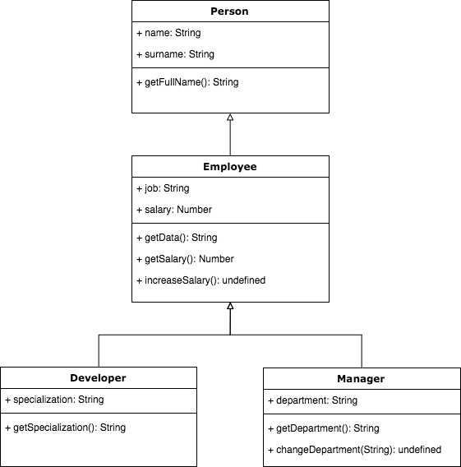

**Applications:**

1. Create constructor functions with properties representing the following:
   * *WebApp*: name, url, technologies, licence, stars
   * *MobileApp*: name, platforms, licence, stars

1. All web applications should inherit methods:
   * *getData* which prints out all the information
   * *reactBased* which checks if one of the used technologies is React

1. All mobile applications should inherit methods:
   * *getData* which prints out all the informations
   * *forAndroid* which checks if one of the platforms the application is developed for is Android
2. Both web and mobile applications should inherit methods:
   * *isCCLicence* which checks if the licence of the application is CC (Creative Commons)
   * *like* which increases the number of stars by one
   * *showStars* which prints out the number of stars